Supplementary Materials: In Vivo Imaging of Local Gene Expression Induced by Magnetic Hyperthermia
Olivier Sandre, Coralie Genevois, Eneko Garaio, Laurent Adumeau, Stéphane Mornet and Franck Couillaud
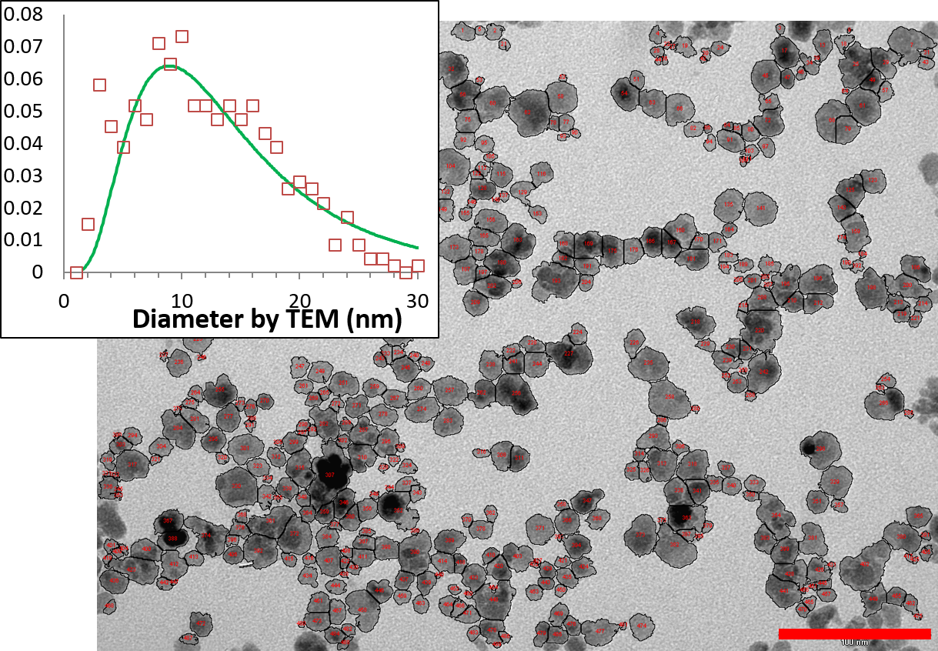
Figure S1. Transmission electron microscopy (TEM) image acquired at 80 kV of C1C2C3 MNP cores diluted at 80 µg/mL analyzed by automated particle counting using ImageJ (https://imagej.nih.gov/ij/). The scale bar length is 100 nm. The histogram shown in inset was built on 464 MNPs, leading to mean diameter and standard deviation: d_{TEM} = 12.4 ± 6.0 nm.
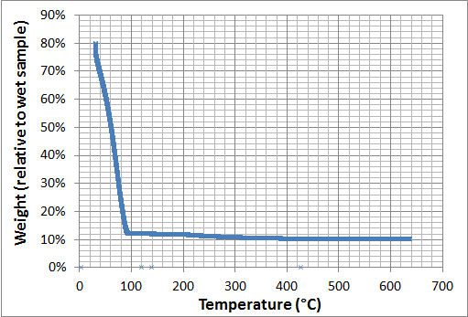
Figure S2. Thermogravimetric Analysis (TGA) curve of C1C2C3@dex MNPs (ramp curve in air, Q500 TA Instruments™, New Castle, DE, USA): dry matter represents 12.0% of which 1.6% is polymer, 10.4% is iron oxide.
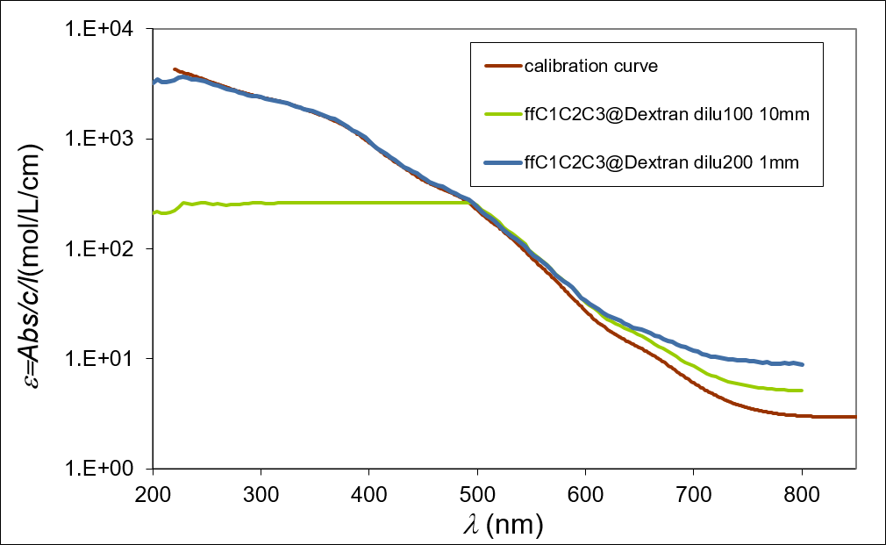
Figure S3. UV-vis absorption spectrum (Spectramax™ M2E, Molecular Devices, Sunnyvale, CA, USA) of C1C2C3@dex MNPs diluted 200 times in water for two optical paths (1 and 10 mm).The calibration curve built on atomic emission spectroscopy enables measuring the iron oxide concentration, here 119.8 g/L.
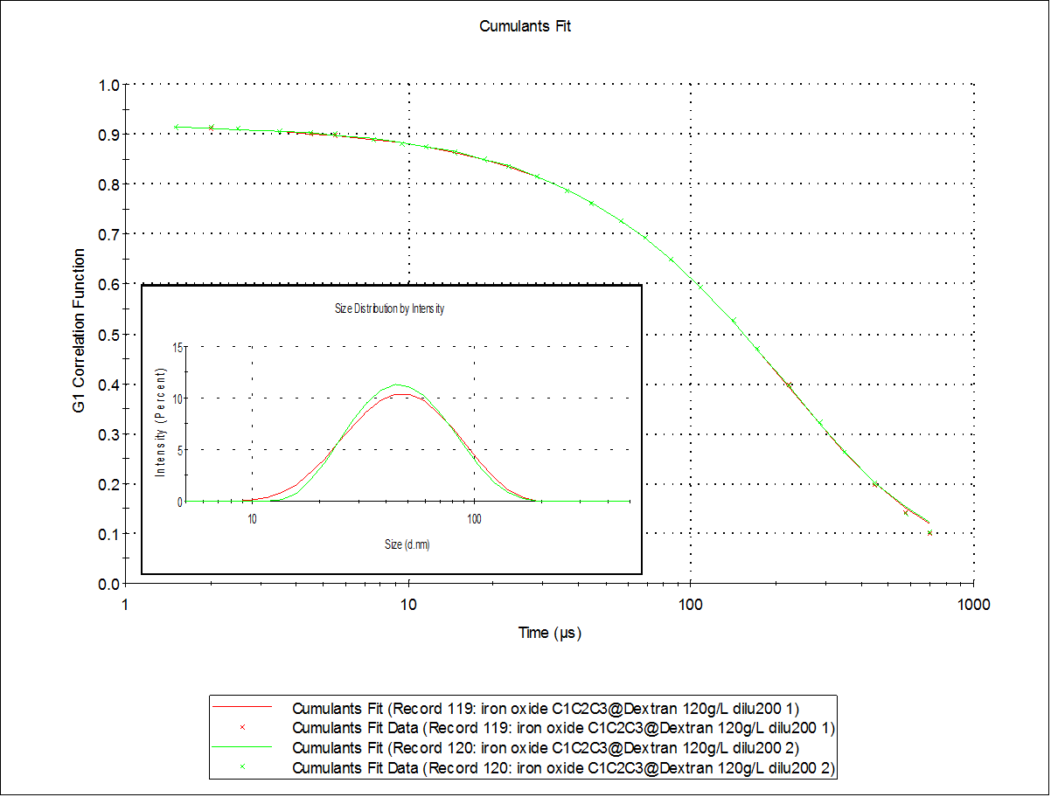
Figure S4. Dynamic light scattering (DLS) curve (Nanosizer™, Malvern Instruments, Worcestershire, UK) of C1C2C3@dex MNPs diluted 200 times in water: the fitting of the correlogram by the method of cumulants leads to a Z-average hydrodynamic diameter of 40.2 nm with a polydispersity index PDI = 0.215.
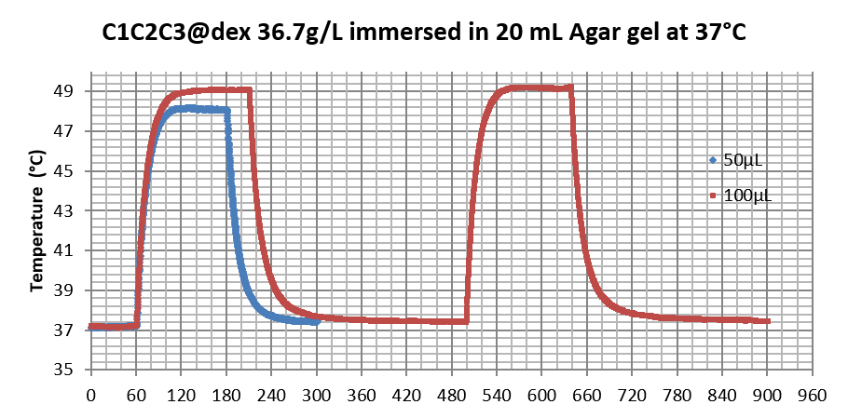
Figure S5. Temperature profiles for C1C2C3@dex magnetic nanoparticles (MNPs) in droplets of two volumes (50 and 100 µL) in contact with 20 mL Agar hydrogel maintained at 37 °C by water circulation to mimic the mouse body. The slopes within the first 3 s enable to deduce the specific absorption rates (SAR) of the MNPs: SAR = 92.6 W/g (50 µL) or 95.3 W/g (100 µL).
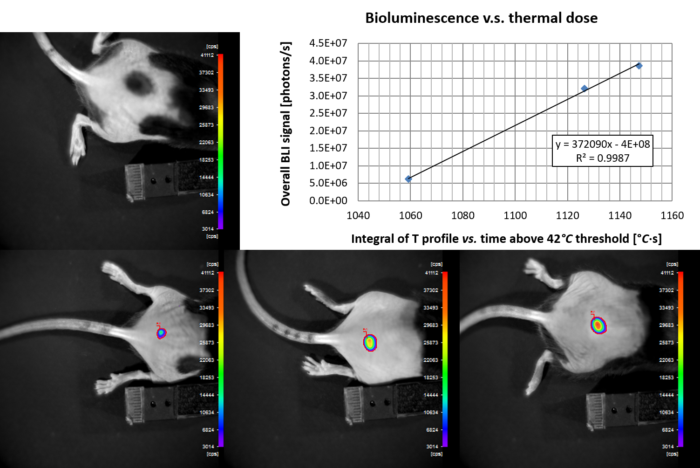
Figure S6. Quantitative relationship between thermal dose and BLI signal for topical deposition of MTN droplet on mouse skin.

